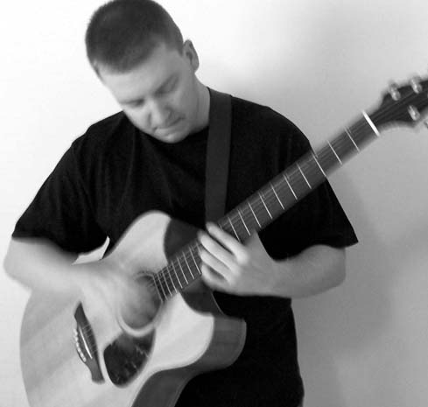

OUT OF THE WOODS
Guitarist strikes a chord in Fort.

by: Matt McClure

Making a transition from a rural small town to a large city can be overwhelming for just about anyone, let alone a musician or troubadour who wants nothing more then to create original music. While not exactly known by outsiders as the next Mecca for aspiring musicians, Fort Wayne's music scene has for years been less than inviting to outsiders testing the creative waters of the city. Yet for others, Fort Wayne offers something different and exciting.
For independent finger-style guitarist, Patrick Woods, coming to Fort Wayne isn't so much overwhelming as it is a blank canvas with musical energy ready to explode. Wearing his avant-garde blend of finger-style guitar, jazz and folk on his sleeve, Woods hopes to wake up the sleeping giants of the city by breaking all the rules.
At age eight he started playing guitar and was plucked from the quiet world of childhood
and into the daydreams of an aspiring musician.

"Back then all I wanted to be was a rock star, like every other kid fantasized about" said
Woods. "As I got older I began to appreciate other styles of music, and that feeling of wanting to make music never really went away. So in junior high and all throughout high school I was in a band and began to experiment with classical and jazz, but at my heart was always playing rock in various progressive forms. I was 18 and someone introduced me to Michael Hedges, the father of acoustic-finger style playing." At that moment everything changed. Since junior high Woods had obsessed over music. Yet when most of his peers were going off to college and partying, joining a rock band and occasionally doing some studying, Woods couldn't help but feel as if there was something more "out there." Even though he was schooled in classical finger picking, percussion, music theory and progressive rock for much of his youth, Woods' musical appetite was for something very, very different.
"Up until that time I was really struggling with what direction should I go as a musician, and what should I do with it" said Woods. "The thing about finger-style guitar is that it blends so many different genres and so you don't really have to settle. The downside is it takes awhile to find your niche."
Instead of waiting, however, for some magical inspiration to illuminate his niche, Woods began to experiment with the different elements of his musical upbringing. He saturated himself with albums from the gods of finger-style music and in waited for his music to distill. After years of work and experimenting with the elements of previous finger-style musicians, Woods' musical wine was ready to be sampled, but not without some hesitation.
"There are a lot of finger-style guitar albums out there" said Woods. "I couldn't imitate. Too
many people are listening to them, and instead of coming up with something new they simply adapt the style to something they already do. An original style starts from day one. Rather than sit around all day and listen to finger-style guitar albums, as inspiring as they are, I decided to play rock and progressive music on an acoustic guitar. There's no accompaniment, no background track. I play everything, the rhythm, melody, all of it."
Yet despite a pseudo original musical voice, Woods' style was still in the fetal stages of
development. He moved to Columbus, Ohio, and in 2000 recorded his first album Nightlands. "I wasn't happy with it," he said. "I recorded it with my acoustic and my 10-string, and the album sounded inconsistent, a little bit of this and a little bit of that. In some sense I guess I was still struggling with where I wanted to be."
Over the next few years Woods played everywhere from cafes to bookstores and small
concert venues, all the while fermenting his music inside the barrel of Columbus' music community. Three years after Nightlands, Woods went back into the studio with new material and a different vision to record Power Fields. Rich in layers and vibrant acoustic energy, Power Fields represented a musical brew that audiences could stand to drink. For some, having a good album and no major record label to distribute would be a problem. Taking a more grassroots approach to distribution than mass marketing, Woods continued to promote his album in any venue that would let him play, developing a very subtle cult following.
Despite growing a very grassroots following, Woods' endurance was reaching its threshold. By
the time he moved back home to Indiana, Woods was spent. Physically exhausted, but creatively
energized. Woods set his sights on Fort Wayne to test the relatively quiet musical waters of the city
and saturate himself with the local musicians.
Instead of gimmicks and cover songs to use as a calling card to venues and audiences alike,
Woods kept to his "music first" approach to connect with Fort Wayne's musical underground.
"It seems as if everybody all over the place wants to sound like Coldplay, Staind or System
of a Down" said Woods, " and while this has been going on since even the 70s, today musicians really only have one shot to make it on a major record label. The general feeling is that if you don't sell at least a half a million copies of your first album you're never going to make it, you'll get shelved. Today's bands will make two or three albums, then break up and release solo albums. Go back to the 70s and look at how many of the successful bands are still together and touring. We just don't give young musicians the same breathing room anymore to create."
Woods now plays regularly at Henry's on downtown Fort Wayne's west side, dishing out his own blend of music to musicians, and onlookers alike. "
"I've found ... a lot of ... people who, through Henry's, have more of an open mind when it
comes to music" said Woods. "Regardless of the fact that I play instrumental finger-style guitar fused with folk and jazz and rock and Celtic, the people who come in really support the music unlike very few other places I've been. Henry's is the first venue I've been to in Fort Wayne where I've met musicians that legitimately care about the music. After the dinner crowd has come and gone the musician crowd starts playing, and then the night gets going. On a good night we don't stop until the early morning hours."
It's this neo-bohemian attitude that drives Patrick during every performance where the music pours out of his fingers to an audience thirsty for something blissfully unusual.

